Appendix C

Qualitative Fish Population Sampling: Survey Notes from Sampling Upstream of Small Stream Diversion Structures and Spring Fry Sampling Results
Table of Contents
Page
Survey Notes of the Fish Distribution Sampling in South Fork Long Canyon Creek, North Fork Long Canyon Creek, and Duncan Creeks Upstream of the Diversions 1
South Fork Long Canyon Creek 2
North Fork Long Canyon Creek 7
Little Duncan Creek 12
Duncan Creek 17
List of Tables
Table C-1. The Upstream Extent of the Fish Distribution in South Fork Long Canyon, North Fork Long Canyon, and Duncan Creeks above the Diversion Dams.
Table C-2. Summary of the Upstream Distribution Sampling for South Fork Long Canyon, North Fork Long Canyon, and Duncan Creeks above the Diversion Dams.
Table C-3. Minimum and Maximum Fork Lengths of Fish Species Caught during Qualitative Sampling for Young-of-the-Year.
List of Maps
Map C-1. 2007 Trout Survey Upper Long Canyon Area.
Map C-2. 2007 Trout Survey Duncan Creek Area.

Survey Notes of the Fish Distribution Sampling in South Fork Long Canyon Creek, North Fork Long Canyon Creek, and Duncan Creeks Upstream of the Diversions

Fish distribution surveys of South Fork Long Canyon Creek, North Fork Long Canyon Creek, Duncan Creek, and Little Duncan Creek were conducted to determine the upstream limit of trout above the diversions. Surveys dates were between 8/13/2007 and 8/16/2007. Two surveyors followed the creek channel and sampled representative pools until the uppermost pool containing trout was reached. The dimensions (length, width, and maximum depth) of all pools, and discharge of the lower elevation pools were measured. The discharge at the pools farther upstream (higher elevation pools) was too small/shallow to be measured. Fish surveys were conducted by visual counts as the leading surveyor approached the pool or by snorkel. The counts were calibrated by conducting visual surveys and single pass electrofishing at three pools. Fish were identified to species and categorized into two age classes Young-of-the-Year (YOY) and juvenile/adult.

Rainbow trout were observed in both South Fork Long Canyon Creek and North Fork Long Canyon Creek. Rainbow trout and brown trout were observed in Duncan Creek and Little Duncan Creek. The numbers of trout observed in each pool loosely correlated with the size of the pool and the magnitude of inflow. A gradual decrease in flow and habitat connectivity was observed as the upstream limit of trout presence was approached. The upper limit of trout was pinpointed for all four streams sampled. Trout inhabited a majority of available habitats. In Duncan Creek and North Fork Long Canyon Creek trout were present until the stream habitat became too shallow or intermittent. In South Fork Long Canyon Creek and Little Duncan Creek the distribution ended at small barriers. It appeared, however, that these barriers limited the distribution due to insufficient flows. The exact upstream limits of trout on all four surveyed creeks may vary between years based on water year type, the magnitude of high spring flows, and the persistence of summer flows.

South Fork Long Canyon Creek
surveyed 8/13/2007

River Mile 5.75
Habitat Type: Plunge pool
Notes: Culvert forms a barrier at low flows
Dimensions: Drop pool is 5.5’ deep 25-30’ wide, 35’ long
Fish Count: Approximately 40 Rainbow Trout (RBT) yearling to adult age range
Flow: 0.13 cfs

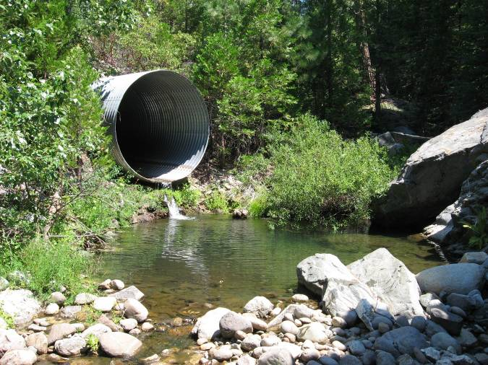

South Fork Long Canyon Creek
surveyed 8/13/2007
River Mile 5.8
Habitat Type: Pool
Notes: None
Dimensions: 15’ wide, 30’ long, 2’ deep
Fish Count: Approximately 15 yearling to adult, 12 young of the year (YOY)
Flow: 0.09 cfs

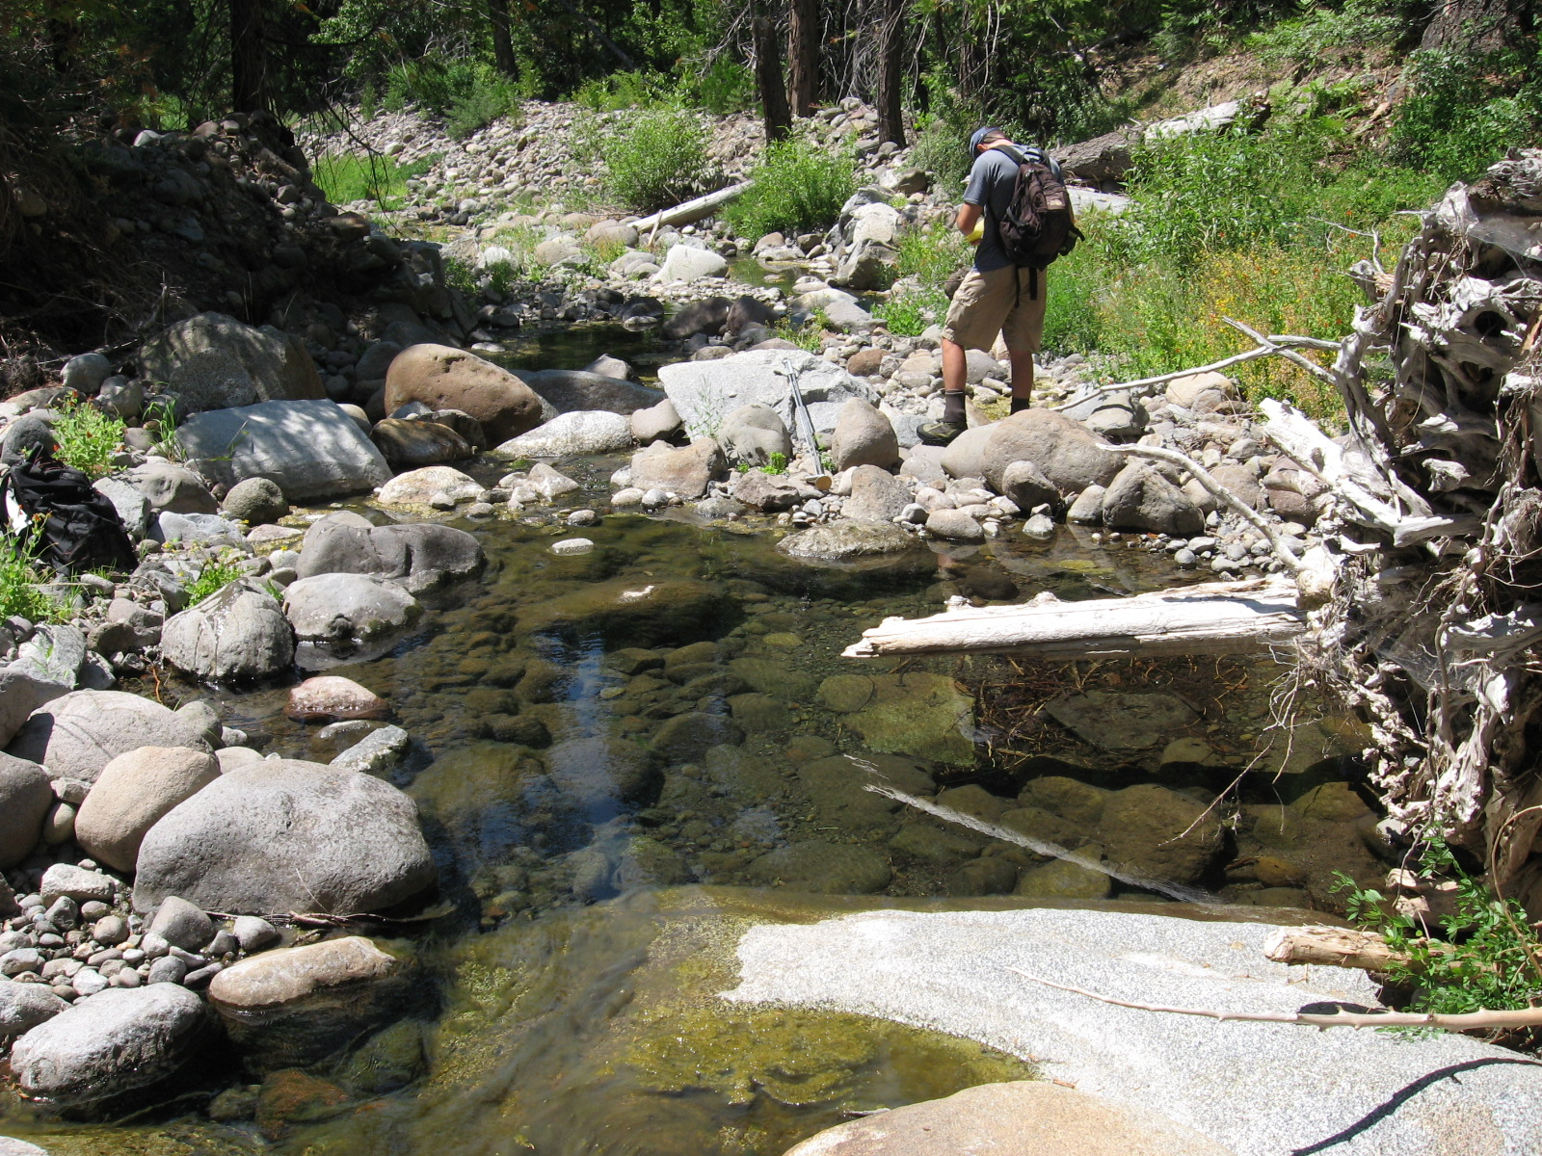
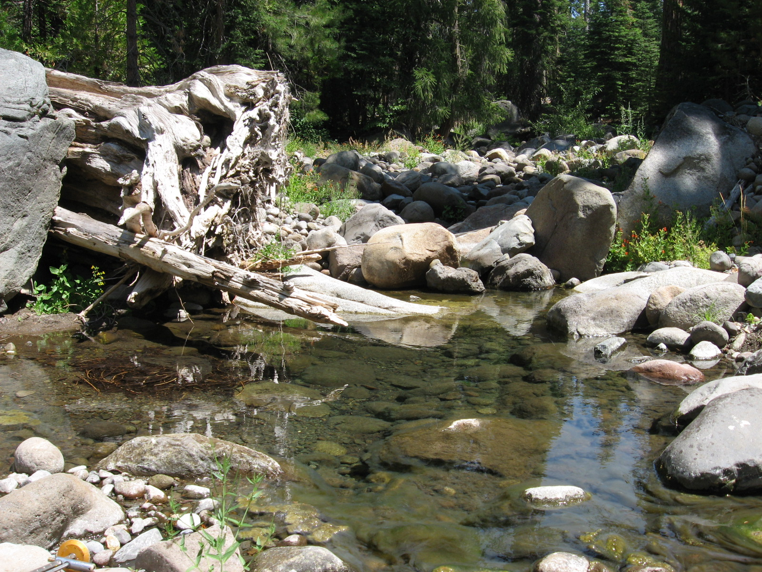

South Fork Long Canyon Creek
surveyed 8/13/2007
River Mile 8.1
Habitat Type: Pool
Notes: None
Dimensions: 15’ long, 6’ wide, 0.95’ deep
Fish Count: Approximately 5 RBT YOY to yearling age range
Flow: Not measurable, stream is intermittent

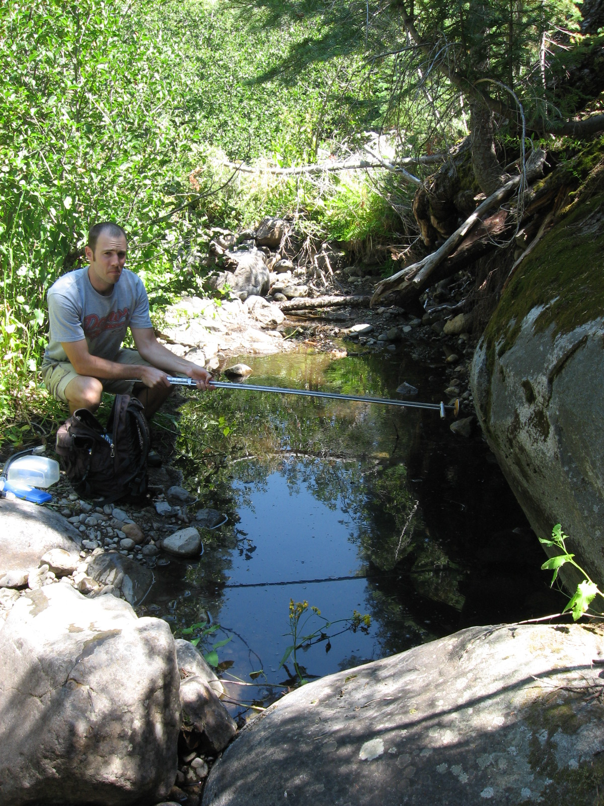
River Mile 8.3
Habitat Type: Pool
Notes: None
Dimensions: Not Available
Fish Count: 1 adult RBT present. Approximately 75 YOY were present in ~400 yards of intermittent pools and riffles
Flow: Not measurable
South Fork Long Canyon Creek
surveyed 8/13/2007 (continued)
River Mile 8.55
Upstream limit of trout in South Fork Long Canyon Creek (survey continued 0.85 miles upstream)
Habitat Type: Pool
Notes: None
Dimensions: 1’ deep, 15’ wide, 15’ long. 6’ tall debris jam at head of pool may act as a barrier
Fish Count: 1 yearling RBT
Flow: Not measurable

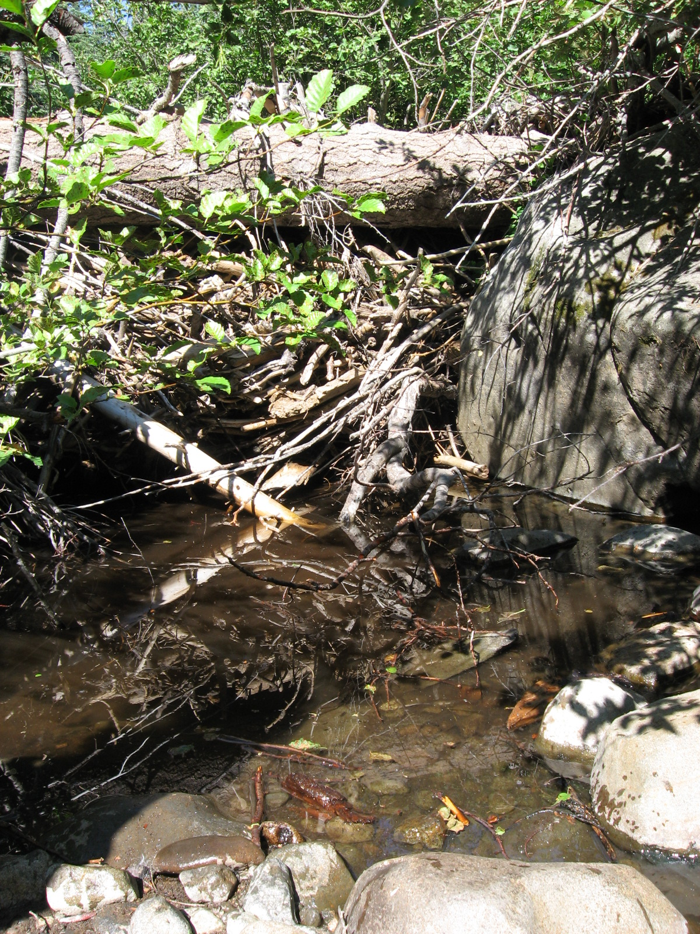
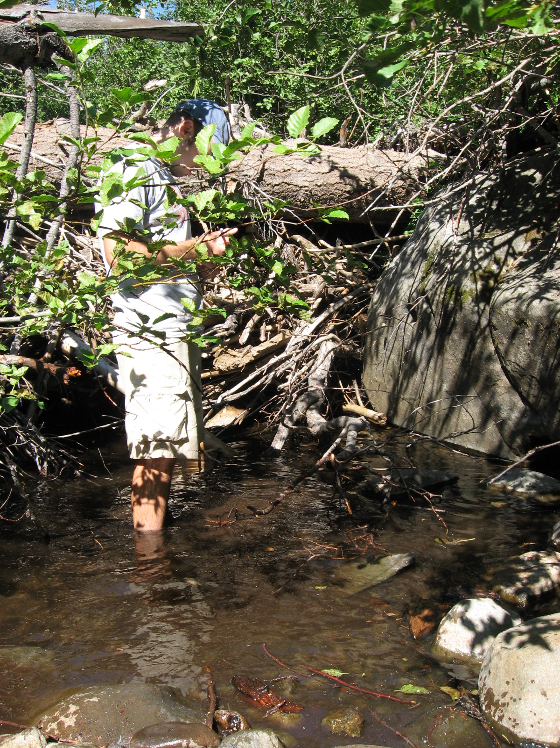

South Fork Long Canyon Creek
surveyed 8/13/2007
River Mile 9.4
Habitat Type: Intermittent small pools
Notes: None
Dimensions: Not Available
Fish Count: No fish
Flow: No surface flow

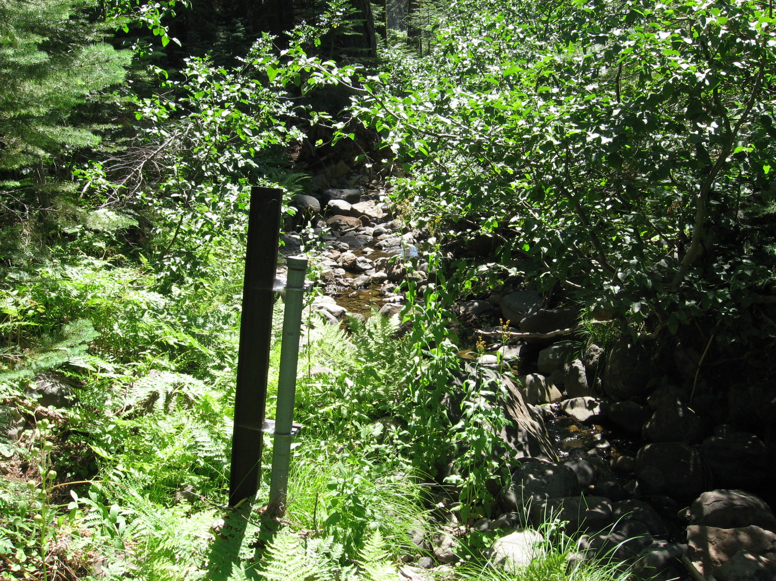

North Fork Long Canyon Creek
surveyed 8/14/2007
River Mile 3.6
Habitat Type: Pool
Notes: Pool was electrofished with a single thorough pass. We compared electrofishing count with visual estimate at three pools
Dimensions: 12’ wide, 22’ long, 1.1’ deep.
Fish Count: Visual - 3 yearling to adult, 2 YOY
E-fishing - 1 adult, 1 yearling, 2 YOY
Flow: 0.2 cfs

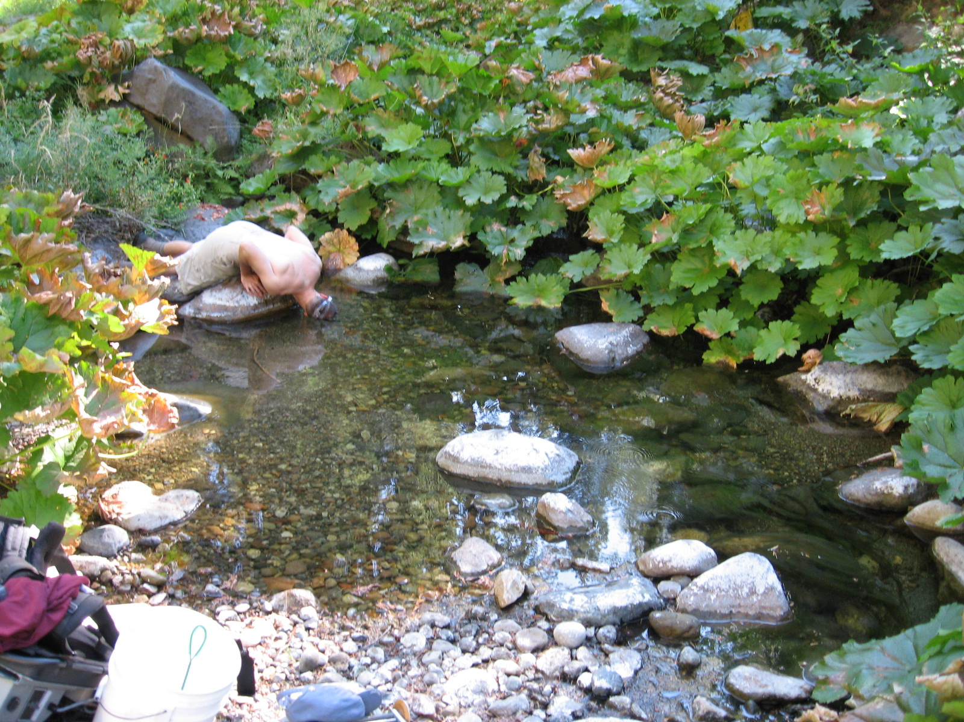

North Fork Long Canyon Creek
surveyed 8/14/2007
River Mile 3.6
Habitat Type: Pool
Notes: None
Dimensions: 13’ wide, 20’ long, 1.7’ deep
Fish Count: Visual - 3 YOY, 10 yearling to adult
E-fishing 3 YOY, 8 yearling, 1 adult
Flow: Same as pool 1.

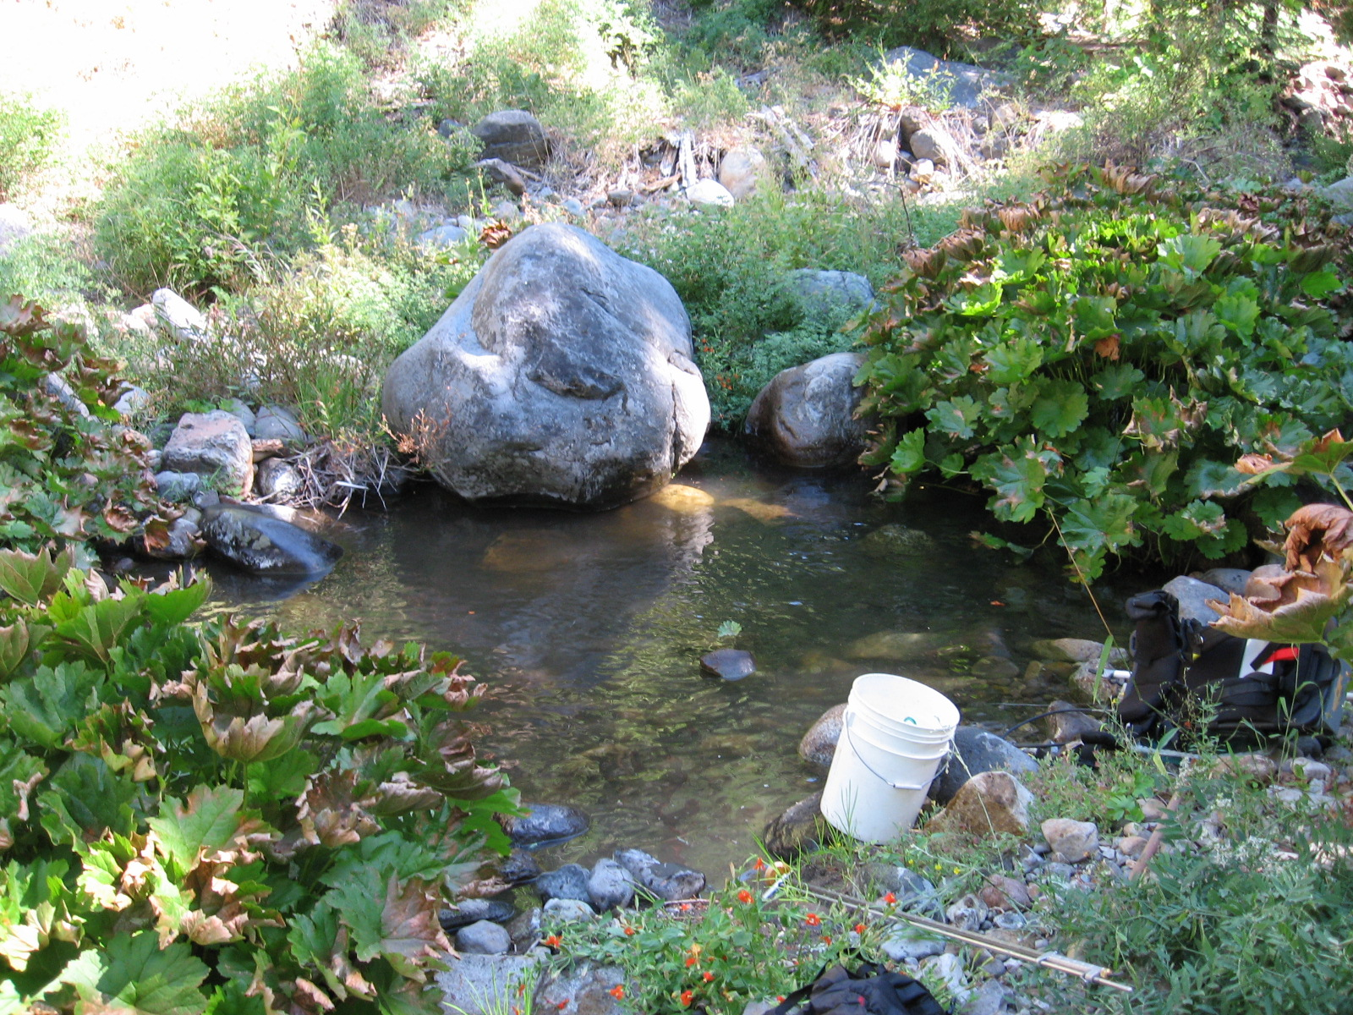

North Fork Long Canyon Creek
surveyed 8/14/2007
River Mile 3.6
Habitat Type: Pool
Notes: None
Dimensions: 12’ wide, 25’ long, 2.6’ deep
Fish Count: Visual - 6-8 YOY, 3 yearling, 2 adult
E-fishing - 6 YOY, 3 yearling, 1 adult, 5-6 yearling to adult were missed
Flow: Same as pool 1

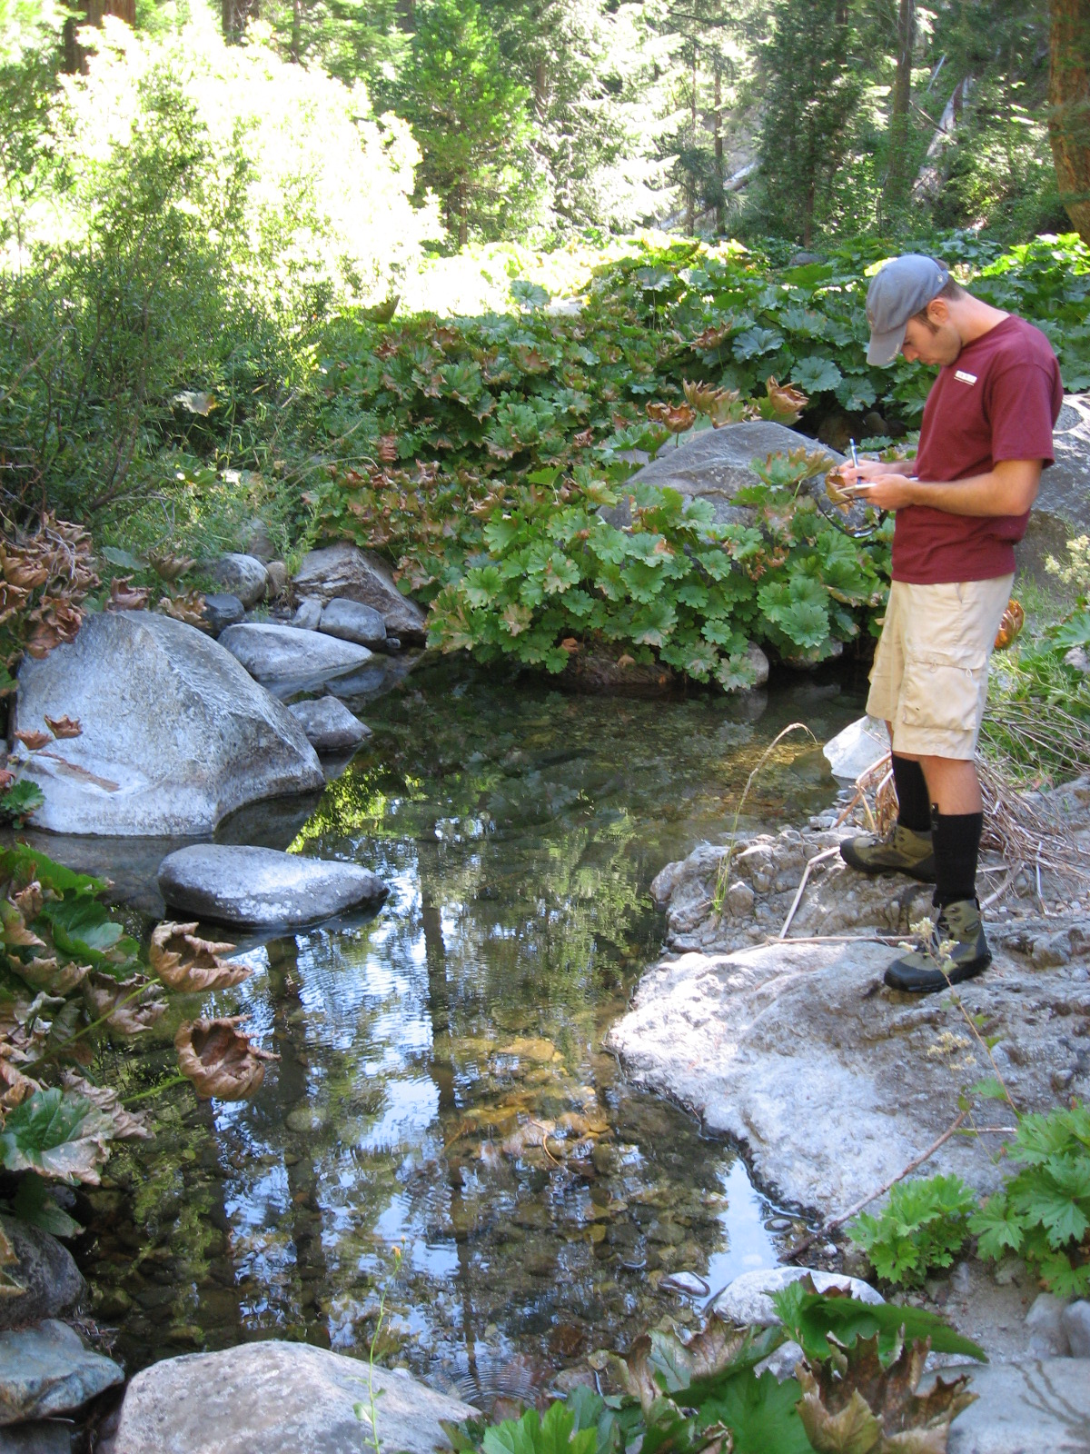

Note: A trial comparison shows that an initial visual count of trout present in the pool had roughly the same accuracy as single pass electrofishing. Visual counts of trout in pools had to be done quickly by the first person to encounter the pool as trout would scatter and hide very quickly. Visual counts from the surface were not able to determine species. In some pools a mask and snorkel were used and species could be identified.
North Fork Long Canyon Creek
surveyed 8/14/2007
River Mile 4.3
Habitat Type: Pool
Notes: Mid-channel pool
Dimensions: 19’ wide, 34’ long, 4.5’ deep
Fish Count: 2 YOY, 14 yearling to adult
Flow: 0.09 cfs

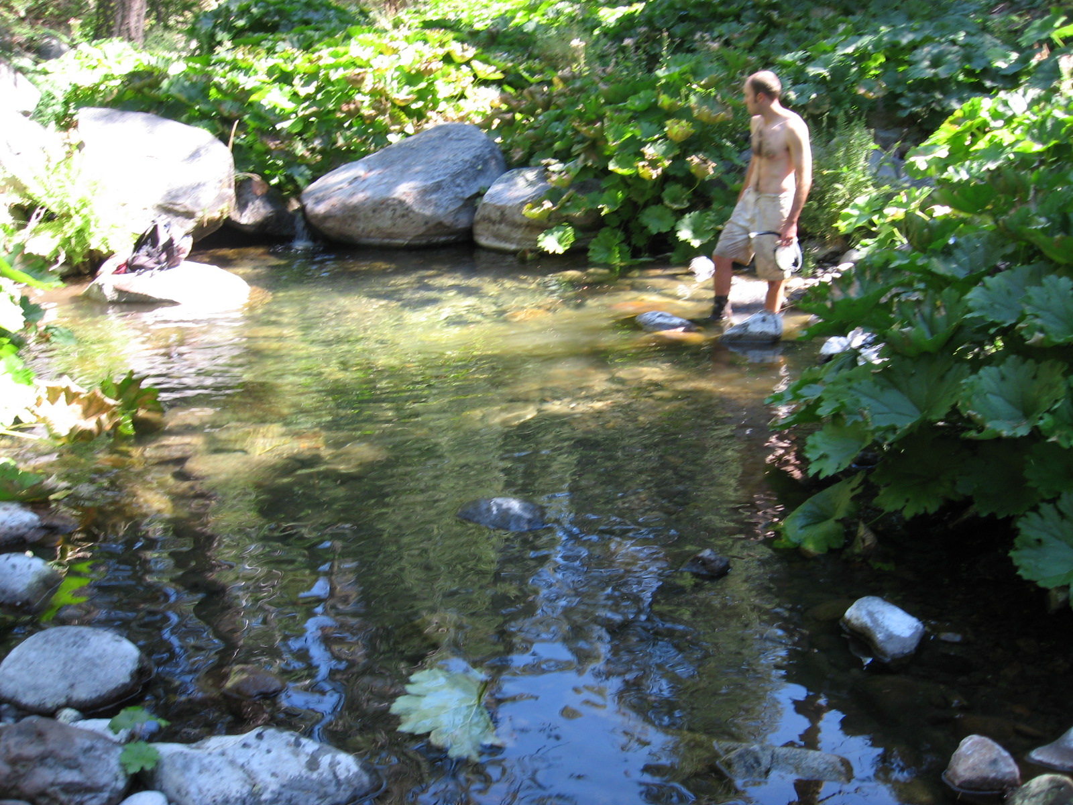

River Mile 4.8
Habitat Type:
Notes: None
Dimensions: 7’ wide, 12’ long, 0.85’ deep
Fish Count: 3 YOY
Flow: Not measurable

North Fork Long Canyon Creek
surveyed 8/14/2007
River Mile 4.9
Upstream limit of trout in North Fork Long Canyon Creek
(survey continued 0.2 miles upstream)
Habitat Type: Isolated pool
Notes: Heavy algal growth, temperature very stratified, channel mostly dry upstream
Dimensions: 6’ wide, 16’ long, 1’ deep
Fish Count: 3 YOY, 1 yearling
Flow: No surface flow

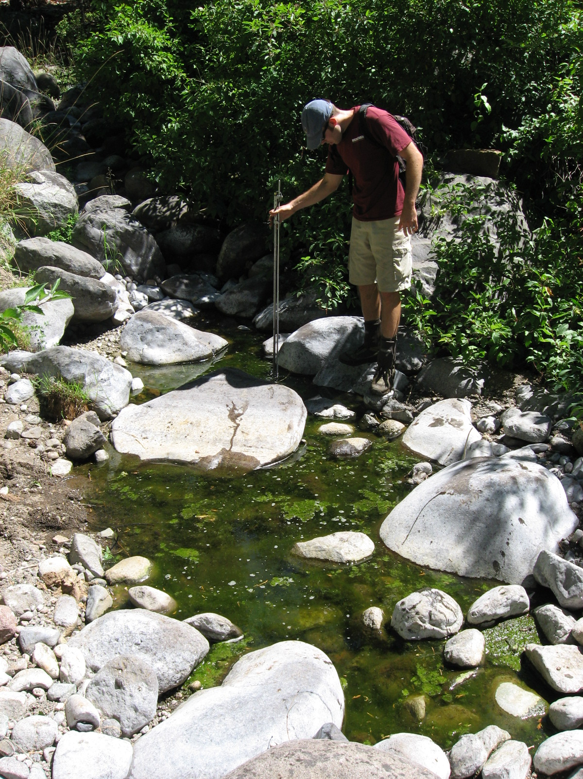

Little Duncan Creek
surveyed 8/15/2007 and 8/16/2007
River Mile 0.45
Habitat Type: Pool
Notes: Creek is very high gradient through this reach with steep bedrock cascades and scour pools and numerous potential migration barriers
Dimensions: Pool 25’ wide, 45’long, 4’ deep
Fish Count: 6 YOY
Flow: 0.07 cfs

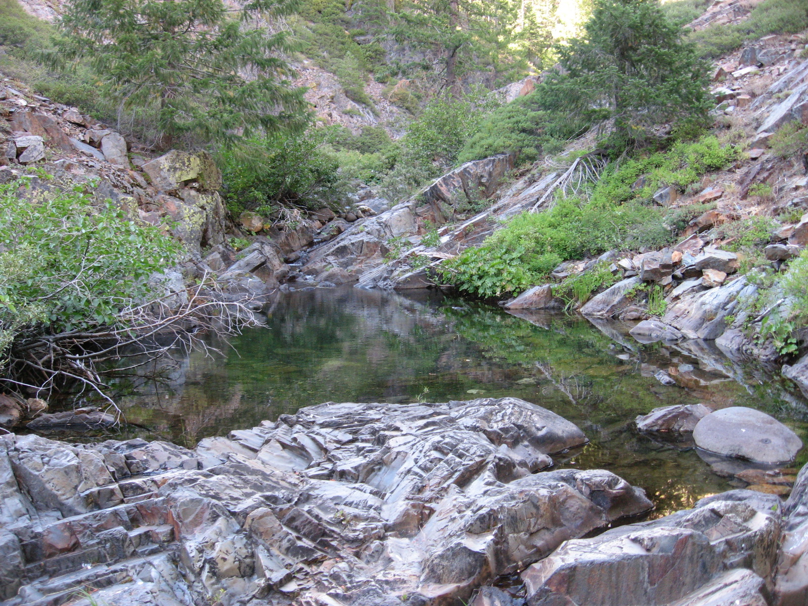

Little Duncan Creek
surveyed 8/15/2007 and 8/16/2007
River Mile 0.8
Habitat Type: Pool
Notes: None
Dimensions: 18’ wide, 35’long, 2.25’ deep
Fish Count: 2 adult
Flow: Not measurable

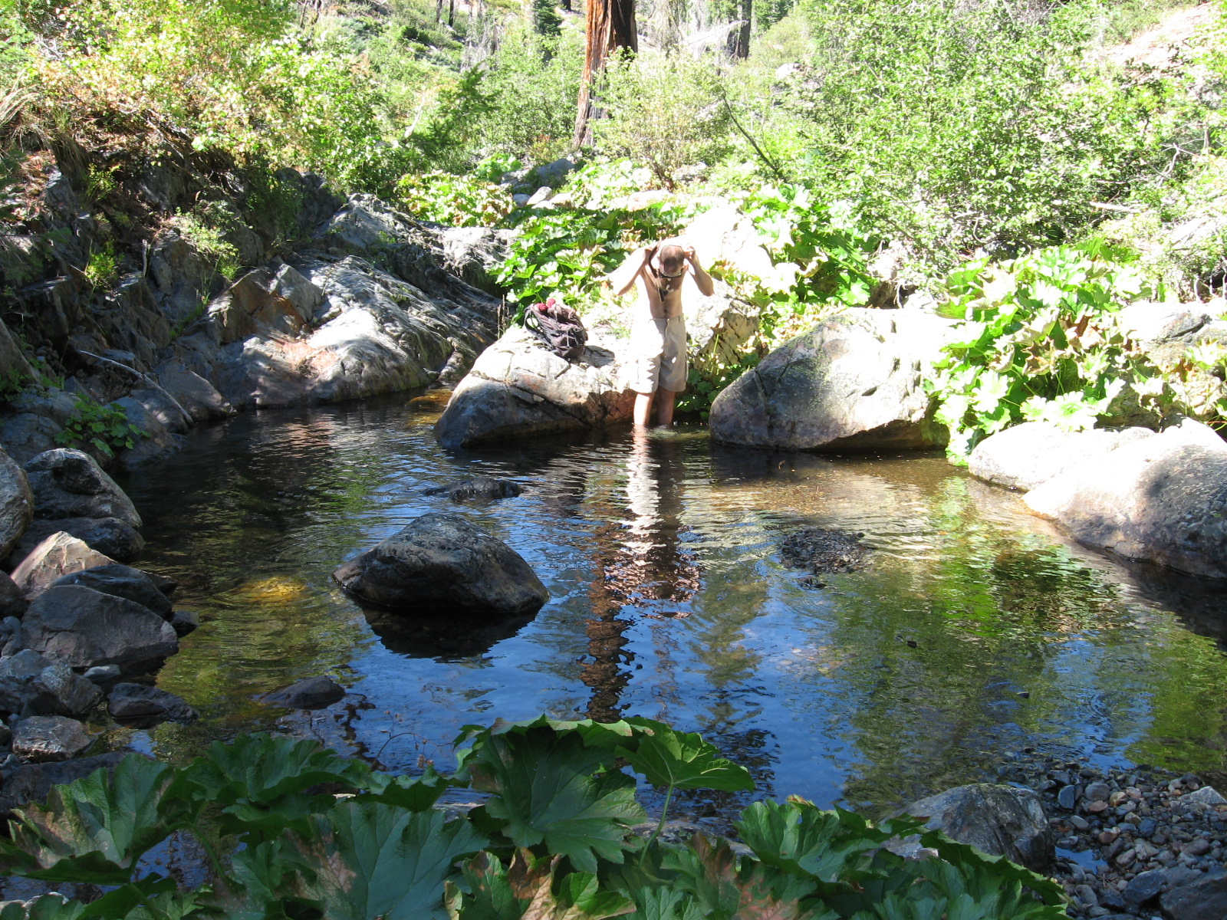

Little Duncan Creek
surveyed 8/15/2007 and 8/16/2007
River Mile 1.2
Habitat Type: Pool
Notes: Confluence of Little Duncan Creek (LDC) headwater and Little Robinson Valley (LRV) headwater. No fish detected on LRV creek ~200 meters above the confluence. Bedrock sheet cascade on LRV creek may be migration impediment
Dimensions: 8’ wide, 20’ long, 1.0’ deep
Fish Count: 2 YOY
Flow: Not measurable

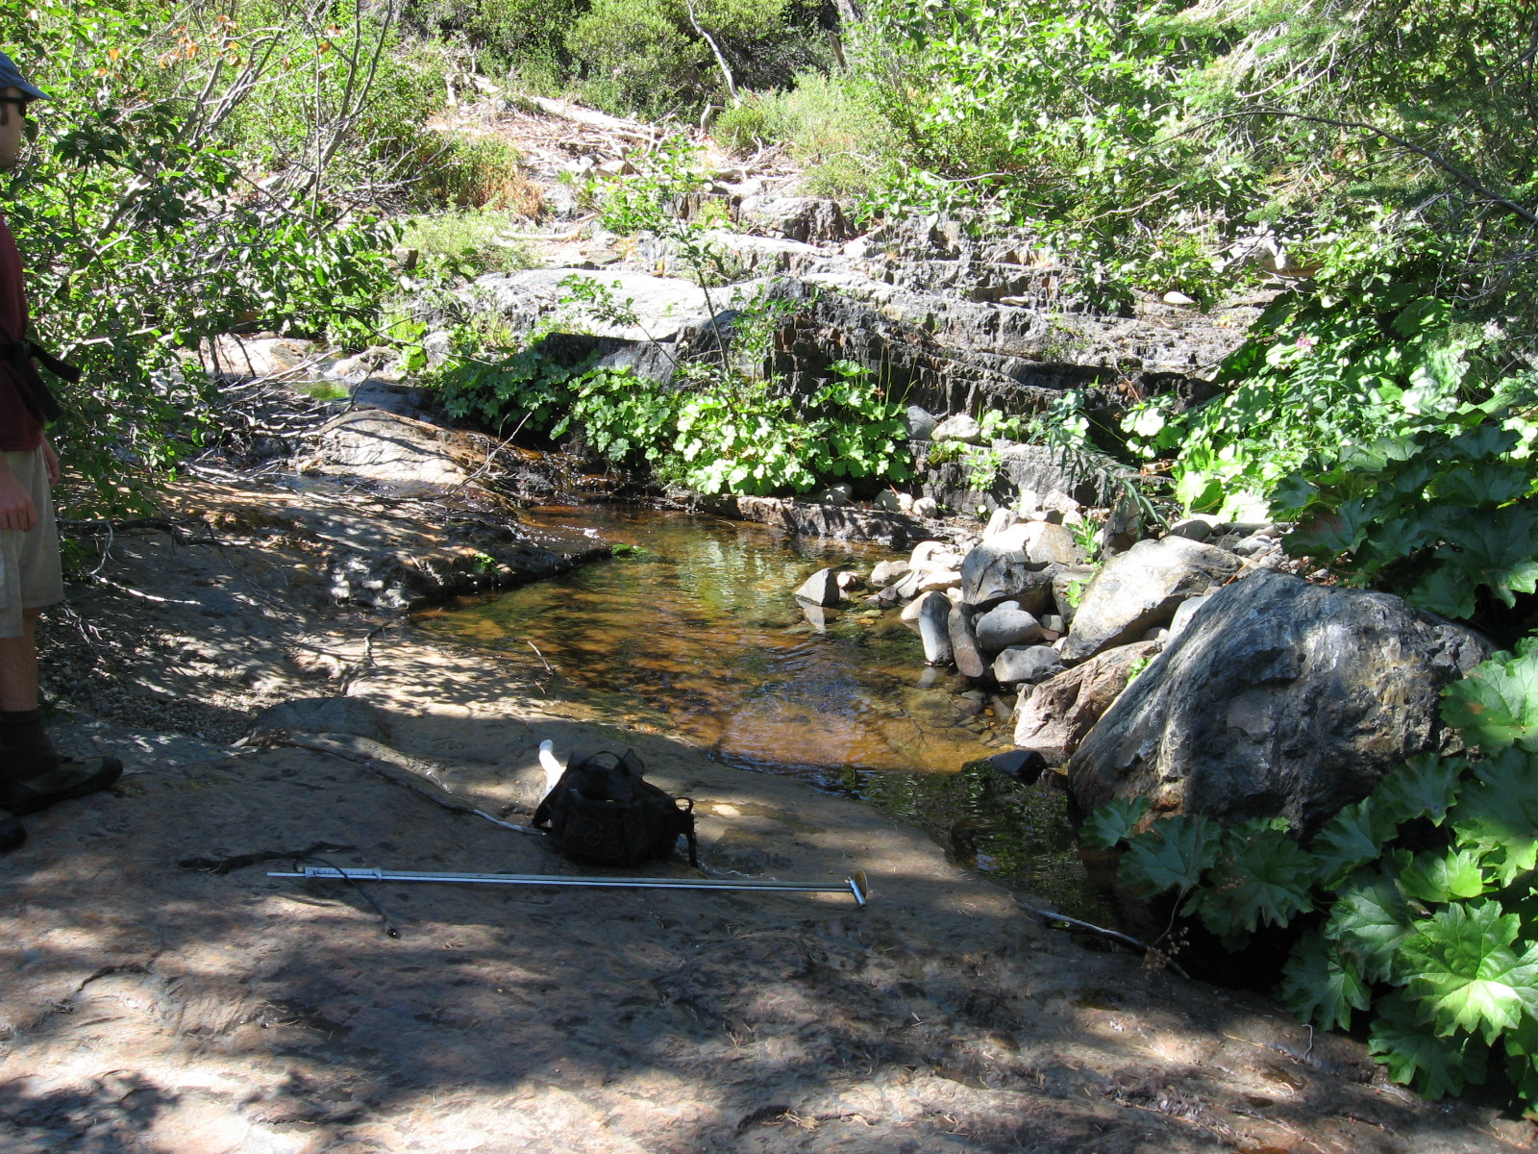

Little Duncan Creek
surveyed 8/15/2007 and 8/16/2007
River Mile 1.2 – Pool 4
Habitat Type: Pool
Notes: LDC headwater above confluence with LRV creek
Dimensions: 7.5’ wide, 17’ long, 0.9’ deep
Fish Count: 2 YOY
Flow: Not measurable

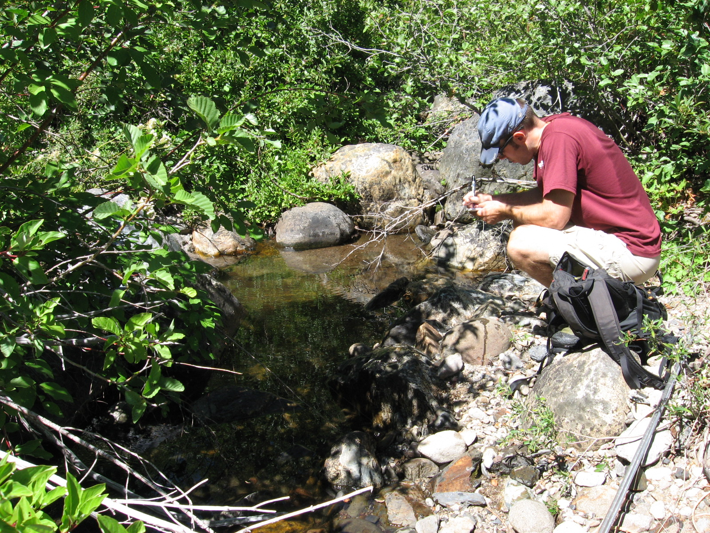

Little Duncan Creek
surveyed 8/15/2007 and 8/16/2007
River Mile 1.3 – Pool 5
Upstream limit of trout in Little Duncan Creek (survey continued 1.4 miles upstream)
Habitat Type: Bedrock Pool
Notes: Upstream passage blocked by steep bedrock sheet cascade. Downstream passage blocked at low flow by cobbles, boulders, and debris. Flow is not measurable. Very low surface flow extends upstream from this pool. Higher bedrock barriers below this point did not appear to affect the distribution of trout. Perhaps there was insufficient flow depth for adult fish to pass this barrier.
Dimensions: 25’ wide, 20’ long, 4.2’ deep
Fish Count: 1 yearling unidentified trout, 1 large adult Brown Trout (BNT)
Flow: Not Available

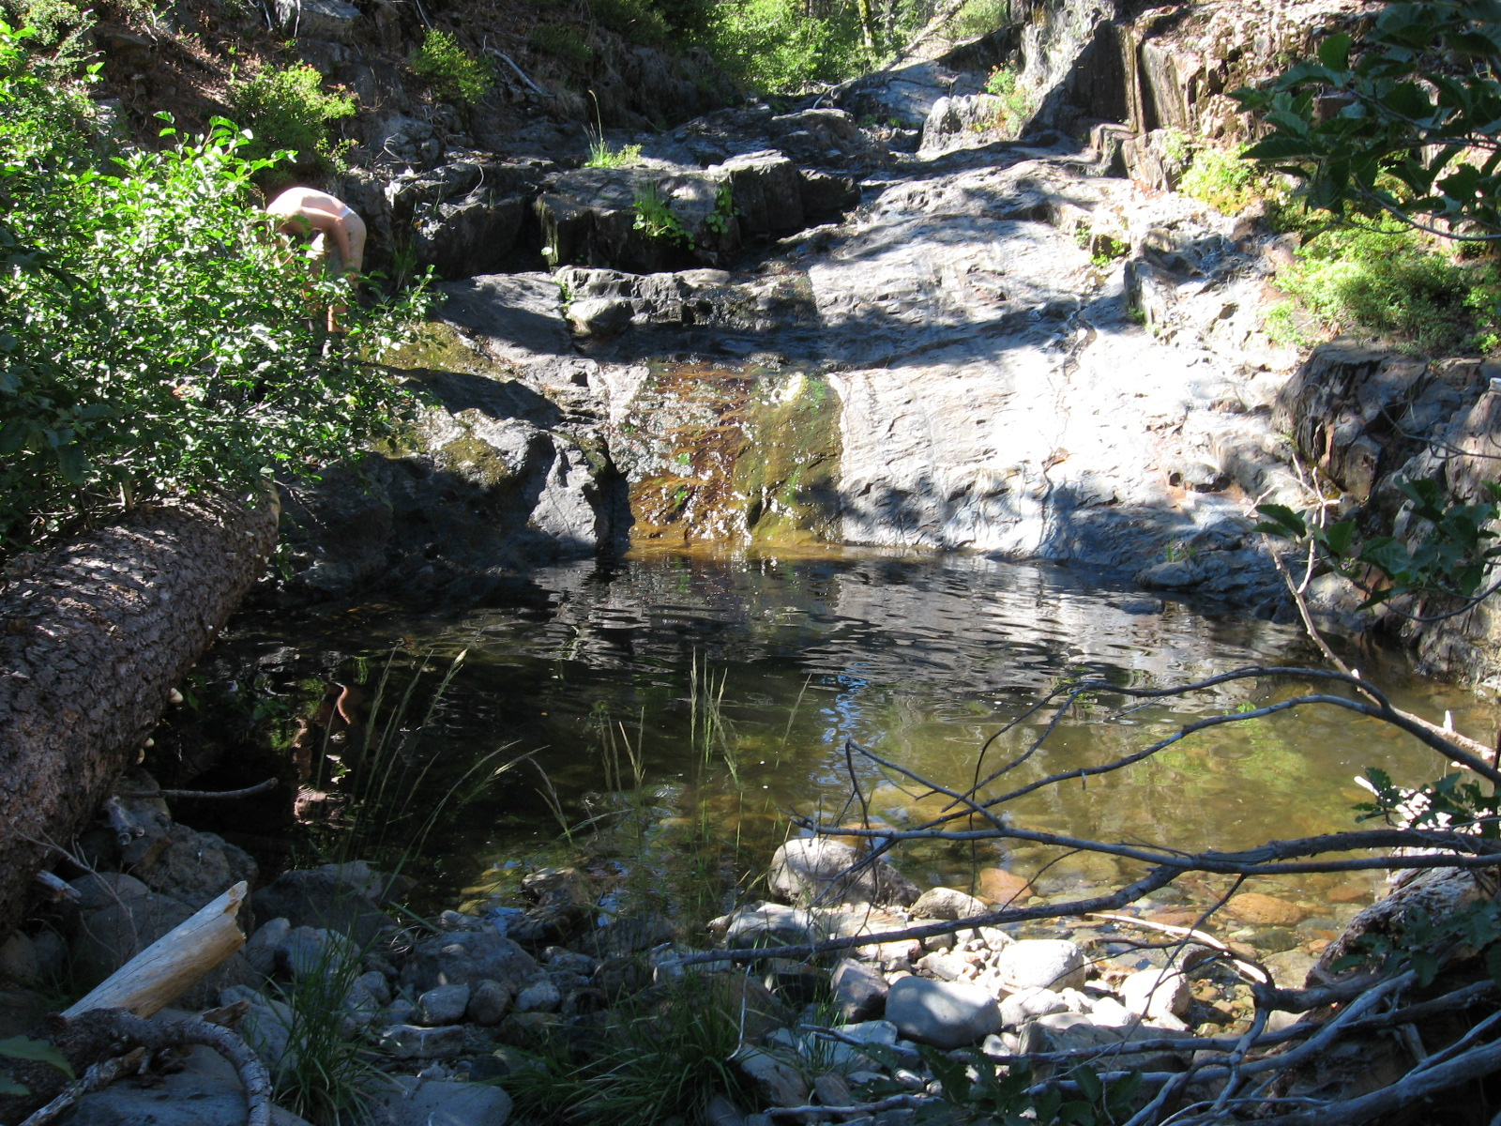

Duncan Creek
surveyed 8/16/07
River Mile 12.4
Habitat Type: Step-Pool
Notes: None
Dimensions: 10’ wide, 28’ long, 1.0’ deep
Fish Count: 2 yearling to adult, 1 YOY
Flow: 0.13 cfs

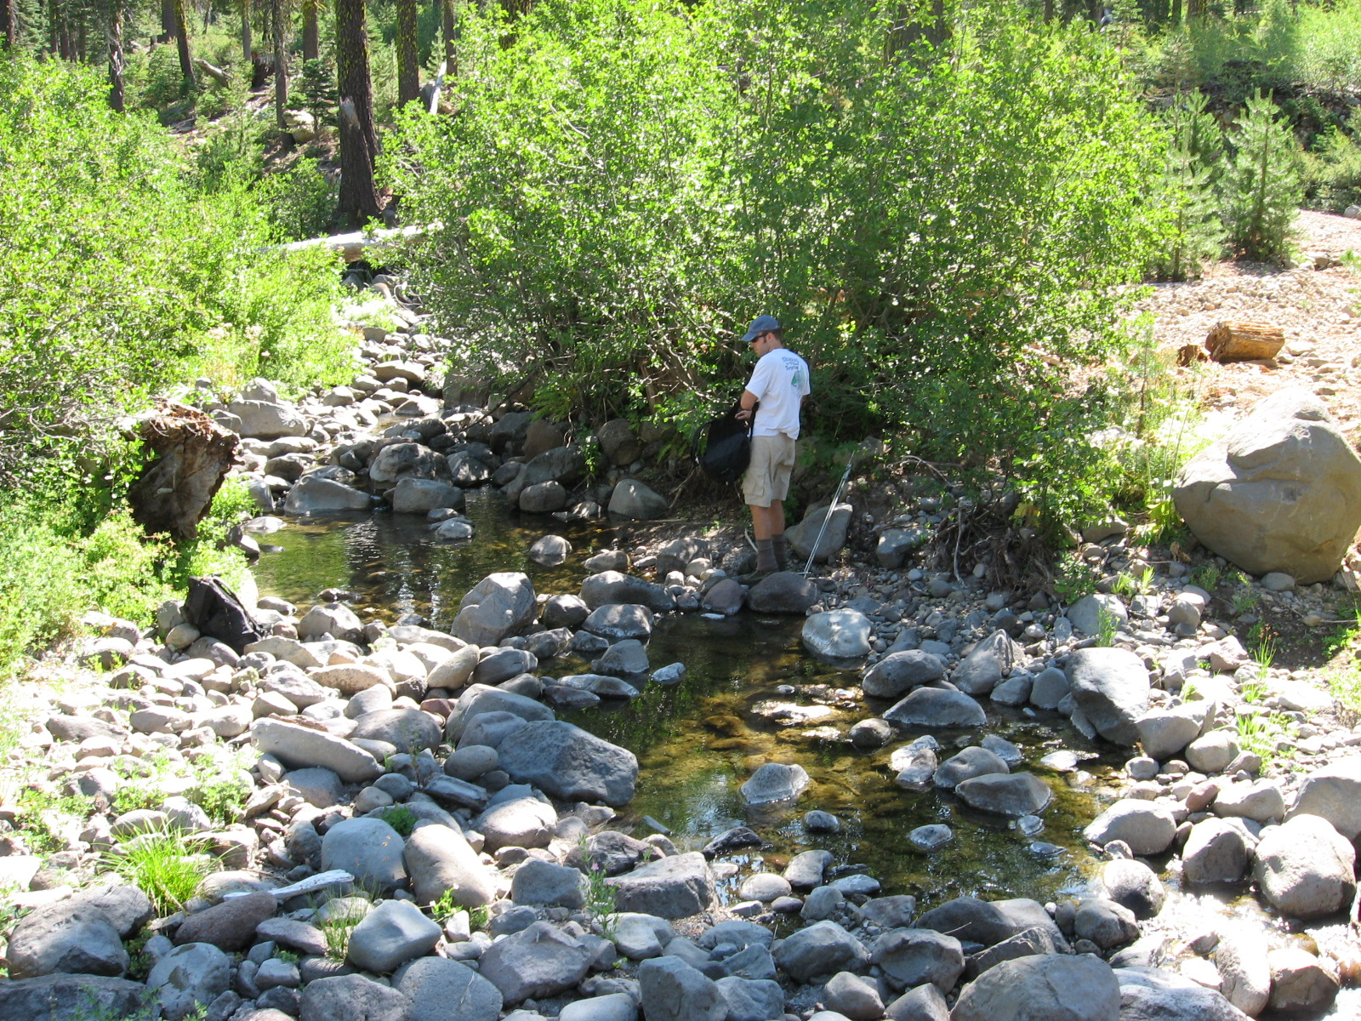

Duncan Creek
surveyed 8/16/07
River Mile 12.5
Habitat Type: Pool
Notes: None
Dimensions: 21’ wide, 60’ long, 1.6’ deep
Fish Count: Approximately 10 yearling to adult
Flow: Similar to pool 1

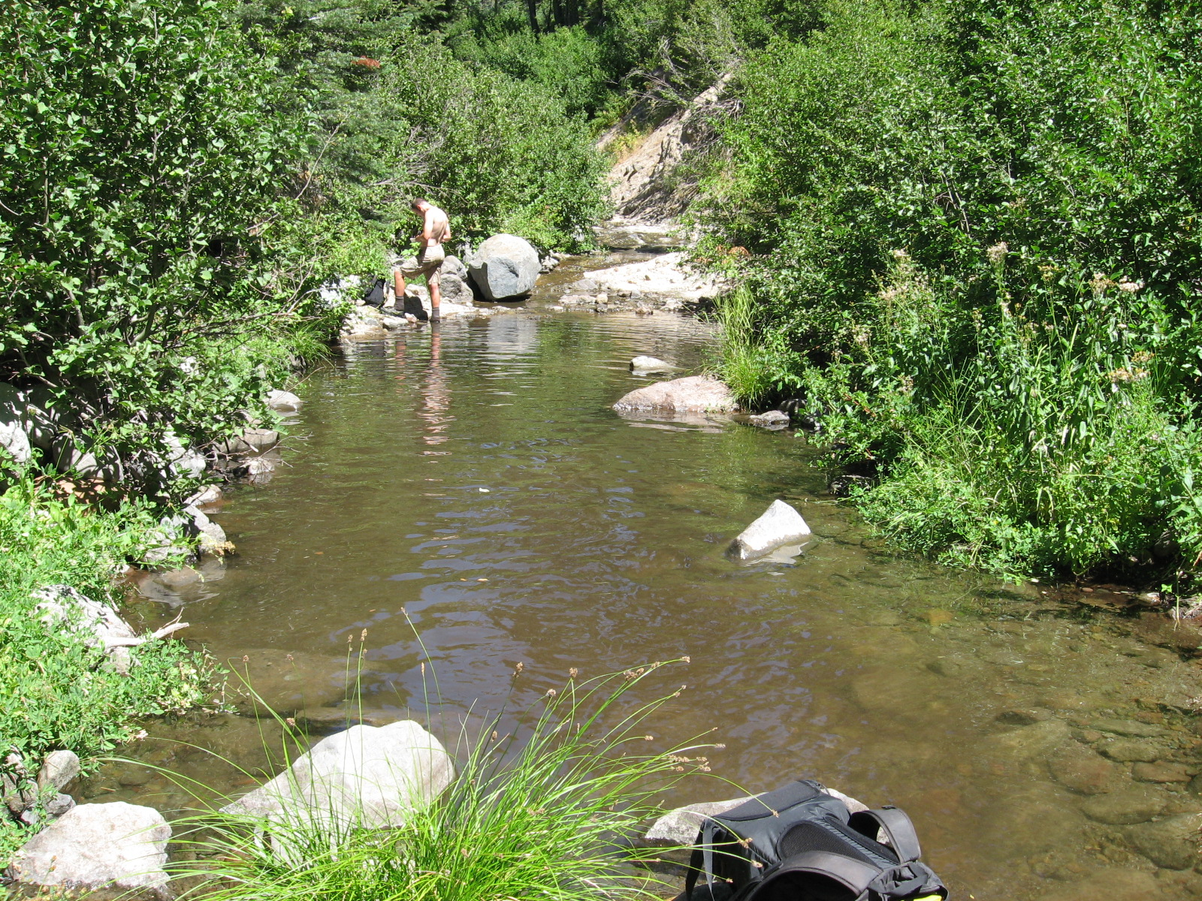

Duncan Creek
surveyed 8/16/07
River Mile 12.85
Habitat Type: Pool
Notes: None
Dimensions: 6’ wide, 20’ long, 1.0’ deep
Fish Count: 2 adult
Flow: Not measurable

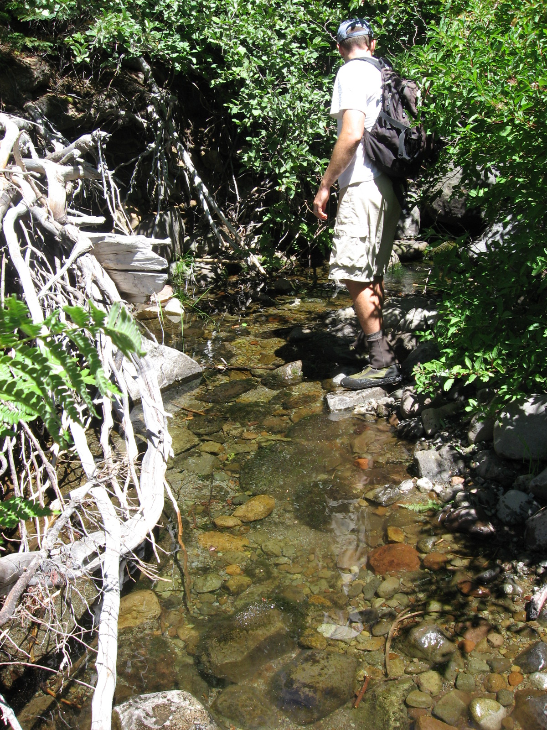

Duncan Creek
surveyed 8/16/07
River Mile 13.3
Upstream extent of trout in Duncan Creek (survey continued 0.3 miles upstream)
Habitat Type: Pool
Notes: None
Dimensions: 8’ wide, 19’ long, 0.75’ deep
Note: Very little habitat upstream, very low surface flow upstream of this point
Fish Count: 3 YOY
Flow: Not measurable

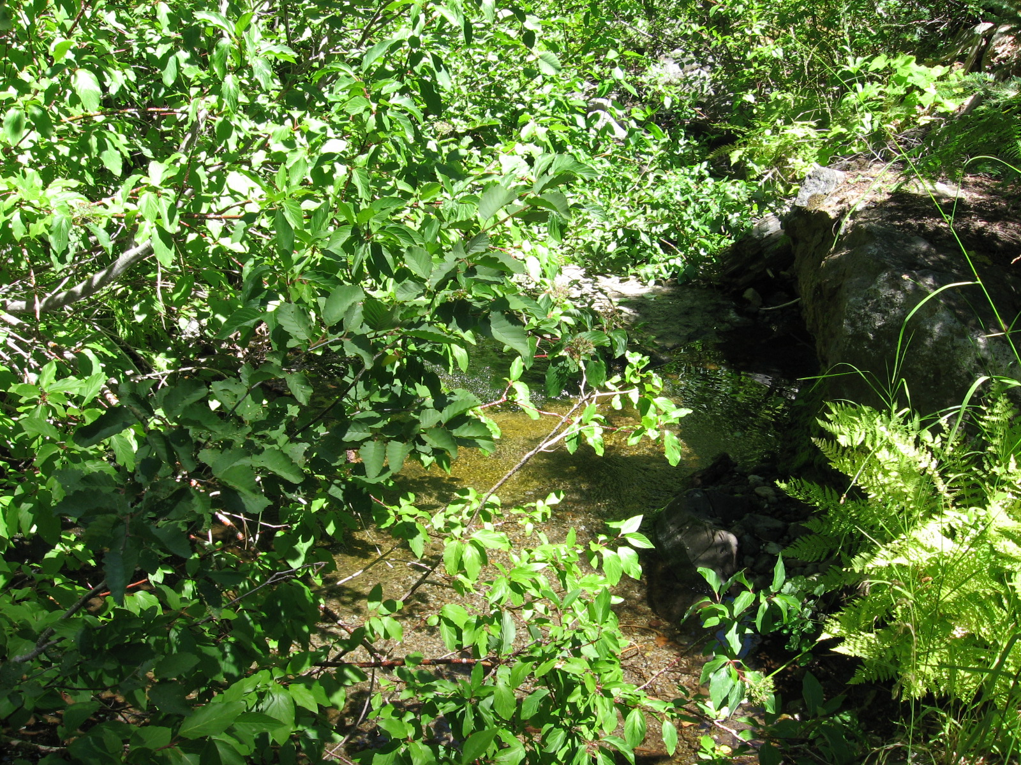

Duncan Creek
surveyed 8/16/07
River Mile 13.6
Habitat Type: Bedrock Sheet
Notes: Upstream extent of survey on Duncan Creek. Flow is only a steep trickle over bedrock and claypan, very little habitat
Dimensions: Not Available
Fish Count: No fish
Flow: Not measurable

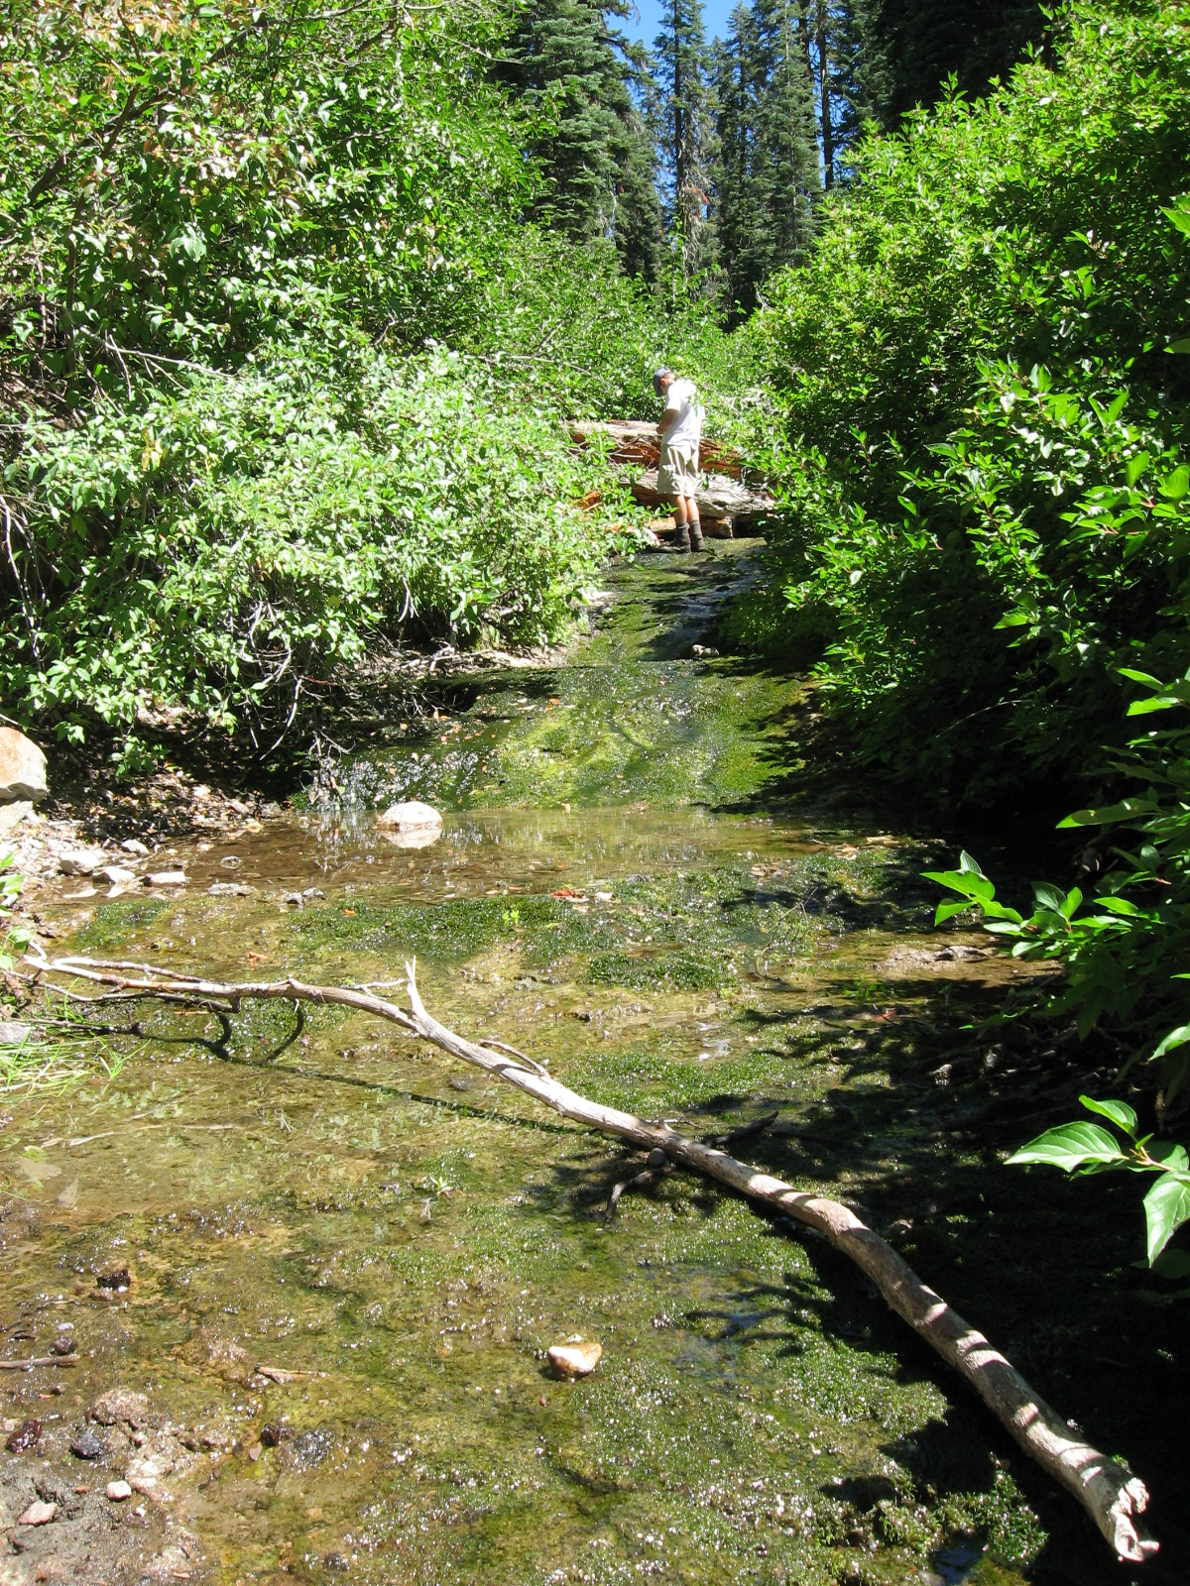

TABLES
MAPS

